# Lambda and Matillion

1. Find functions definitions in the calling Matillion Python module
2. Go to Lambda AWS > Test and provide key / value pairs from the function definitions for the code as defined in the Matillion job based on the Payload from Matillion.

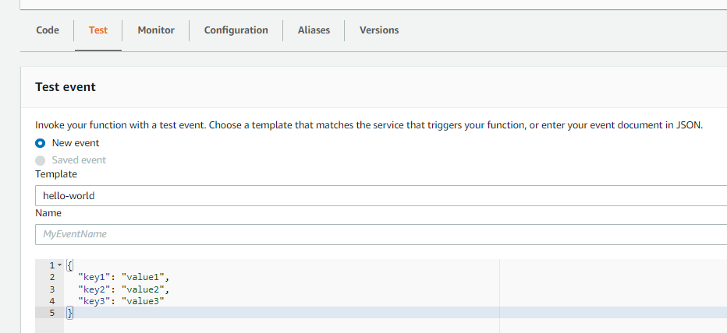

1. Add print functions to the Lambda code
2. Press test

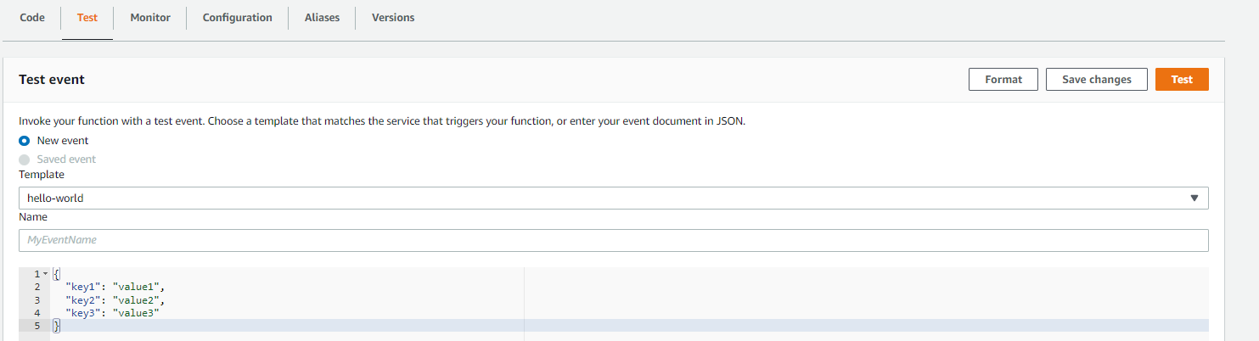

1. And then select Monitor and view logs to see test behavior

